Power System Survivability
Norbert Doerry
October 1, 2026
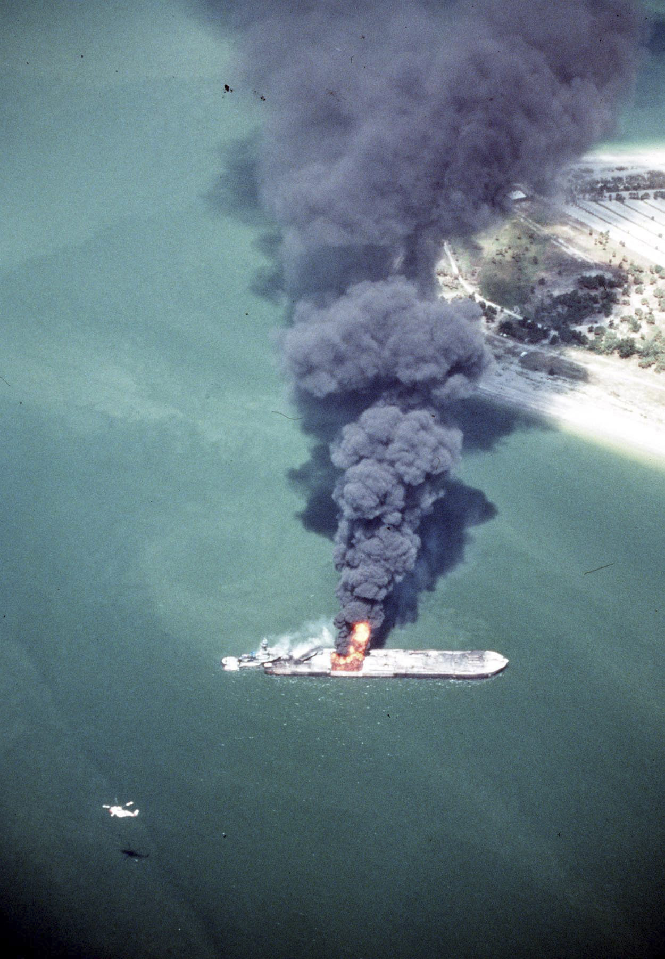
(U.S. Coast Guard Photo: image is in the public domain)
- Introduction
Survivability is a term used to describe the ability of a system to operate following exposure to a threat. For shipboard systems, threats that are common between commercial and naval applications include fire, flooding, collision, vandalism, and cyber-attacks. Naval ships also are subject to threats from weapon systems such as mines, torpedoes, missiles, rockets, bombs, drones and guns.
For a given ship, design threats are those that a ship is designed to address; design threat outcomes are the capabilities that the ship is expected to retain or restore following exposure to a threat. Overmatching threats are those that may result in loss of the ship; the ship is not expected to retain capability after exposure to an overmatching threat.
With respect to exposure to a threat, a ship response may address the three elements of survivability: Susceptibility, Vulnerability, and Recoverability. Susceptibility measures how well the ship avoids the threat such that the ship does not experience damage. Vulnerability measures how well the ship is able to retain capability when the ship is exposed to the threat and possibly damaged. Recoverability measures how well the ship is able to restore lost capability following exposure to a threat.
Shipboard electrical power system design typically relies upon the overall ship design process to address susceptibility. Shipboard electrical power system design does typically address vulnerability and recoverability.
For ships that employ a zonal design, zonal survivability addresses vulnerability and compartment survivability addresses recoverability. For ships that do not employ a zonal design, vulnerability and recoverability are typically addressed through modeling and simulation; Many scenarios are modeled and the design is altered if any scenario predicts insufficient performance. Dynamic positioning levels DP-2 and DP-3 address vulnerability in addition to their primary objective of propulsion system reliability.
- Zonal design
In zonal design, the ship is subdivided geographically into multiple zones. Each zone is comprised of one or more watertight subdivisions and extend vertically into the superstructure (if present). The goals of zonal design are to limit damage from a non-overmatching threat to at most two adjacent zones; preserve sufficient capability in the undamaged zones to meet vulnerability requirements for design threat outcomes; and provide the ability to restore sufficient capability in damaged zones to meet recoverability requirements for design threat outcomes.
The number of zones and the boundaries between zones are total ship design decisions. The ship designer should consider the following when establishing the number and boundaries of the zones:
- Zones should be large enough such that non-overmatching damage to the ship due to an initiating event (such as grounding, collision, fire, or weapon effects) does not extend beyond two adjacent zones. Ships are not designed to survive overmatching damage.
- Zone boundaries should be designed to preclude fire spreading or progressive flooding to extend beyond the initial one or two damaged zones. Zone boundaries should be watertight and should have an A-60 fire rating as defined by SOLAS Chapter II-2. The fire protection system should be designed to detect and extinguish fires as quickly as possible; for non-overmatching threats, fires should be extinguished in no more than 60 minutes.
- For ships required by SOLAS to have the capability for safe return to port, the casualty threshold for fire is no larger than a single zone. In a similar manner, the flooding requirement of any single watertight compartment is also no larger than a single zone. The boundaries of zones should be selected such that the systems required to remain operational by SOLAS have sufficient redundancy across zones.
- With any two adjacent zones damaged, there should be sufficient capability remaining in the undamaged zones to achieve the survivability objectives of the ship.
- For systems required to be operational following damage and have multiple single points of failure, the single points of failure should ideally be located in the same zone.
- For systems required to be operational following damage and have redundancy, redundant capability should ideally be located in different zones that are not adjacent.
- A ship with a two-compartment damaged stability requirement can satisfy the flooding criteria with zones that span at least a single watertight subdivision. A ship with a three-compartment damaged stability requirement can satisfy the flooding criteria with zones that span at least two watertight subdivisions.
IEEE Std. 45.1 provides the following guidance:
“The maximum number of zones is often determined by the ship’s damaged stability requirements. Damaged stability can be specified as the ability to stay afloat in terms of either the number of watertight compartments that can be flooded (typically 2 or 3 for complex ships) or the length of damage to the hull that the ship can sustain (typically 10% to 20% of the ship’s length). The rules for determining compartmentation size are specified by regulations, customer requirements, and international agreements.
The zone size should be large enough such that for every condition of flooding where the ship is required to remain afloat, at most two adjacent zones are flooded. This typically places an upper bound on the number of zones to be between 10 and 20, depending on the particular damage stability requirements of a ship.
The optimal number of zones is typically based on a utility function heavily weighted on cost. Typically, the fewest number of zones that can support zonal survivability for all distributed systems and mission systems is the lowest cost. For this reason, the power system designer should work with the principal naval architect and the other system design leaders to determine the number of zones and zone boundaries.”
Figure 1depicts a low voltage ac zonal distribution system. In this system, zones 1 and 5 do not have generator sets; the bus ties / load center feeder cables to their adjacent zone and zone 3 and the port and starboard bus switchboards should be protected to maximize the chances of survivability of a source of power for these two zones. Critical loads are connected via a bus transfer device (either automatic bus transfer – ABT or manual bus transfer – MBT) to both the port and starboard busses.
Where possible, one or more generator sets should be located in the forward most and the aft most zones. If sufficiently rated, the generator sets in the end zones should be capable of providing power to undamaged zones.
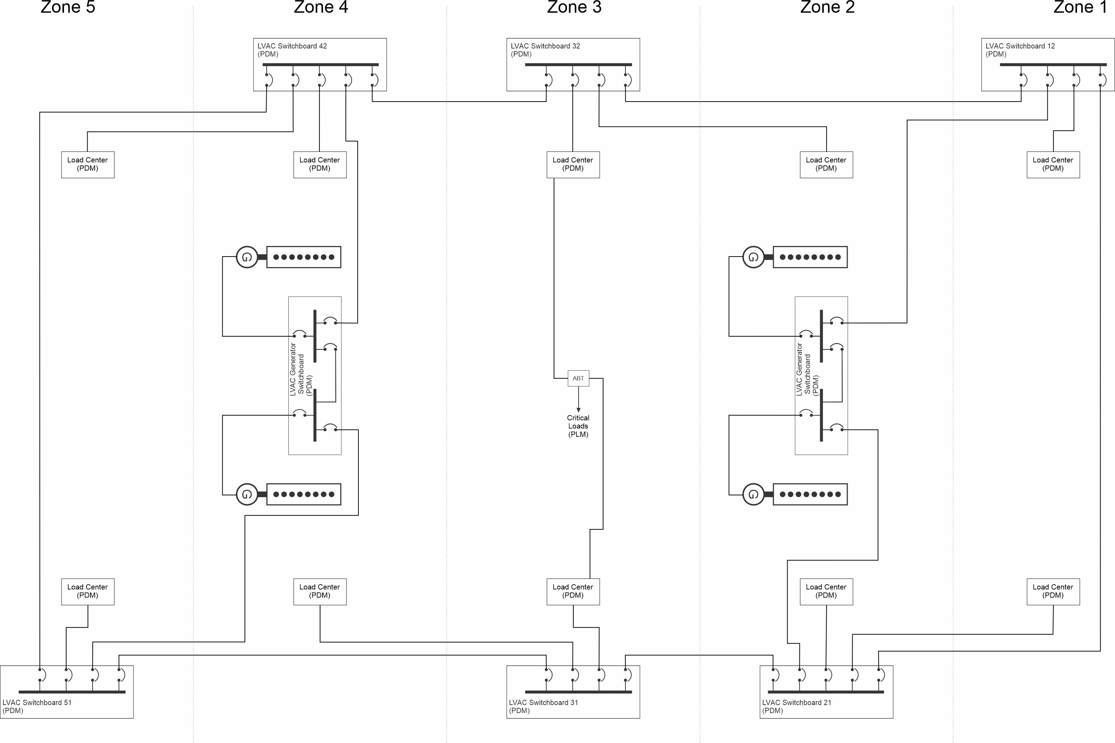
Figure 1: Low voltage ac zonal electrical distribution system
- Zonal survivability
  - Definition
IEEE Std 45.1 defines zonal survivability as
“For a distributed system, such as the electrical distribution system, zonal survivability is the ability of the distributed system, when experiencing internal faults due to damage or equipment failure confined to adjacent zones, to ensure loads in undamaged zones do not experience a service interruption. Because a bounding watertight subdivision transverse bulkhead can be damaged, zonal survivability assumes that two adjacent zones can experience damage due to a single event. The zones should be large enough such that no more than two zones are damaged due to a single event that the ship is expected to survive.”
  - Design implications
IEEE Std 45.1 states:
“Zonal survivability assures damage does not propagate outside the adjacent zones in which damage is experienced. For many distributed system designs, zonal survivability requires that at least one longitudinal bus remains serviceable, even those that are routed through damaged zones; the design and routing of these longitudinal buses should maximize the probability of at least one bus through a damaged zone surviving in the case of a damaging event.”
“The requirement for power generation to survive damage to two adjacent zones implies that the minimum number of zones is three; the generator sets (or groups of generator sets) should be separated with at least one complete zone between them. The generators, or groups of generator sets, should have sufficient capacity to power loads connected to them following damage. Usually, however, it is difficult to locate generator sets in the forward-most zone; the hull narrows at the bow, and the ability to arrange intake and exhaust trunks is challenging. As a result, the first zone with a generator set is often the second zone, necessitating a fourth zone to achieve the required separation of generator sets. Similarly, the design of the superstructure, such as the incorporation of a helicopter deck at the fantail, may prevent locating a generator set in the aft-most zone. Thus, a fifth zone may be required. Note that the minimum number of zones may be due to arrangement constraints of other distributed or mission systems.”
If energy storage is employed for generation capacity, then it should have sufficient energy to power the necessary loads to achieve the design threat outcome for as long as it takes to provide a more permanent connection or until the design threat outcome is no longer needed.
A casualty power system that is used to “jumper” over damaged zones to interconnect bus switchboards in undamaged zones is one way to provide the more permanent connection. Energy storage should have sufficient energy capacity to serve its loads for the one hour to extinguish the fire plus the time required to rig the casualty power system (typically 30 minutes).
  - Emergency lighting and power systems
For U.S. commercial ships, 46 CFR 112 requires ships to have an emergency lighting and power system …
“The purpose of this part is to ensure a dependable, independent, and dedicated emergency power source with sufficient capacity to supply those services that are necessary for the safety of the passengers, crew, and other persons in an emergency and those additional loads that may be authorized under paragraph (c) of this section.”
One can interpret emergency loads, which are enumerated (for the U.S.) in 46 CFR 112, as the regulatory design threat outcome for commercial ships. 46 CFR 112 is written however, assuming the ship does not incorporate zonal design; it presumes a single emergency generator (or source) and a single emergency switchboard. The single emergency switchboard is a single point of failure. Figure 2 depicts an architecture where the single emergency switchboard is replaced with zonal emergency switchboards. These zonal emergency switchboards are powered from the LVAC switchboards under normal conditions; and by the emergency generator when power is lost at the LVAC switchboards. If the emergency loads have sufficient redundancy and assigned to appropriate emergency switchboards, the survivability of the emergency capabilities is much improved over the traditional single emergency switchboard.
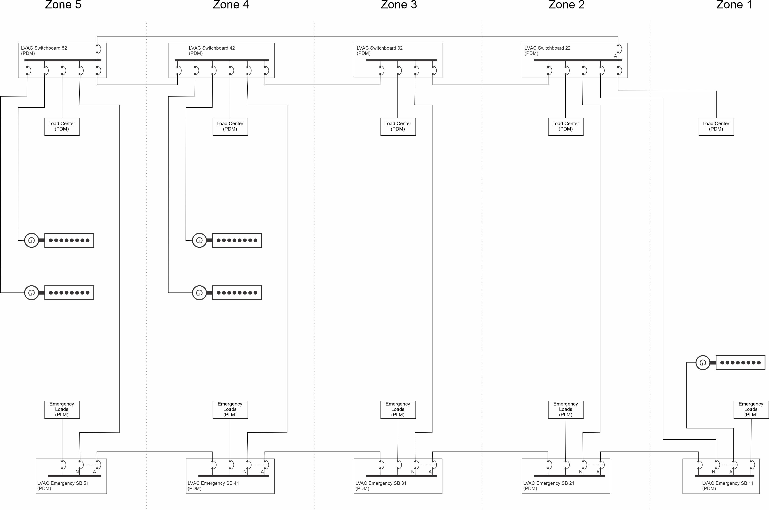
Figure 2: Low voltage ac zonal electrical distribution system with zonal emergency switchboards
The use of zonal emergency switchboards may require regulatory approval. In the U.S. 46 CFR 110.20-1 states:
“The Commanding Officer, Marine Safety Center (MSC), may approve any arrangement, fitting, appliance, apparatus, equipment, calculation, information, or test that provides a level of safety equivalent to that established by specific provisions of this subchapter. Requests for approval must be submitted to the Marine Safety Center. If necessary, the Marine Safety Center may require engineering evaluations and tests to demonstrate the equivalence of the substitute.”
This process may be appropriate when employing a zonal emergency distribution system.
- Compartment survivability
  - Definition
IEEE Std 45.1 defines compartment survivability as:
“Compartment survivability addresses the ability to recover loads within a damaged zone. In many cases, the damaging event does not damage all of the equipment within a zone. Critical equipment, such as the emergency loads, should have a means of restoring power to them if they are verified to be undamaged and will not cause a hazard if energized.”
Compartment survivability applies to zones that have been damaged; zonal survivability applies to zones that are undamaged.
  - Design implications
IEEE Std 45.1 states:
“Compartment survivability is usually achieved by providing an alternate source for each distributed system that the load requires. For the electrical power system, switching from the normal to an alternate source is accomplished through either a manual bus transfer or an automatic bus transfer. On some naval ships, a casualty power system is provided to enable the rigging of temporary power cables from a load center or switchboard to the critical equipment.”
Figure 3 depicts an automatic bus transfer (ABT) switch. In a zonal system with port and starboard buses, the normal source and the alternate source of power should be on opposite buses (typically zonal load centers). If neither zonal load center is connected to a zonal switchboard within the zone, then one zonal load center should be connected to a switchboard in a zone forward of it, and the other to a switchboard aft of it (and connected to the opposite bus) as depicted in Figure 4 for the critical load in zone 3. This configuration prevents loss of power to the bus transfer due to loss of a single zone. In Figure 5, the loss of zone 4 results in potentially both zone 3 load centers losing power; this configuration should be avoided if at all possible.
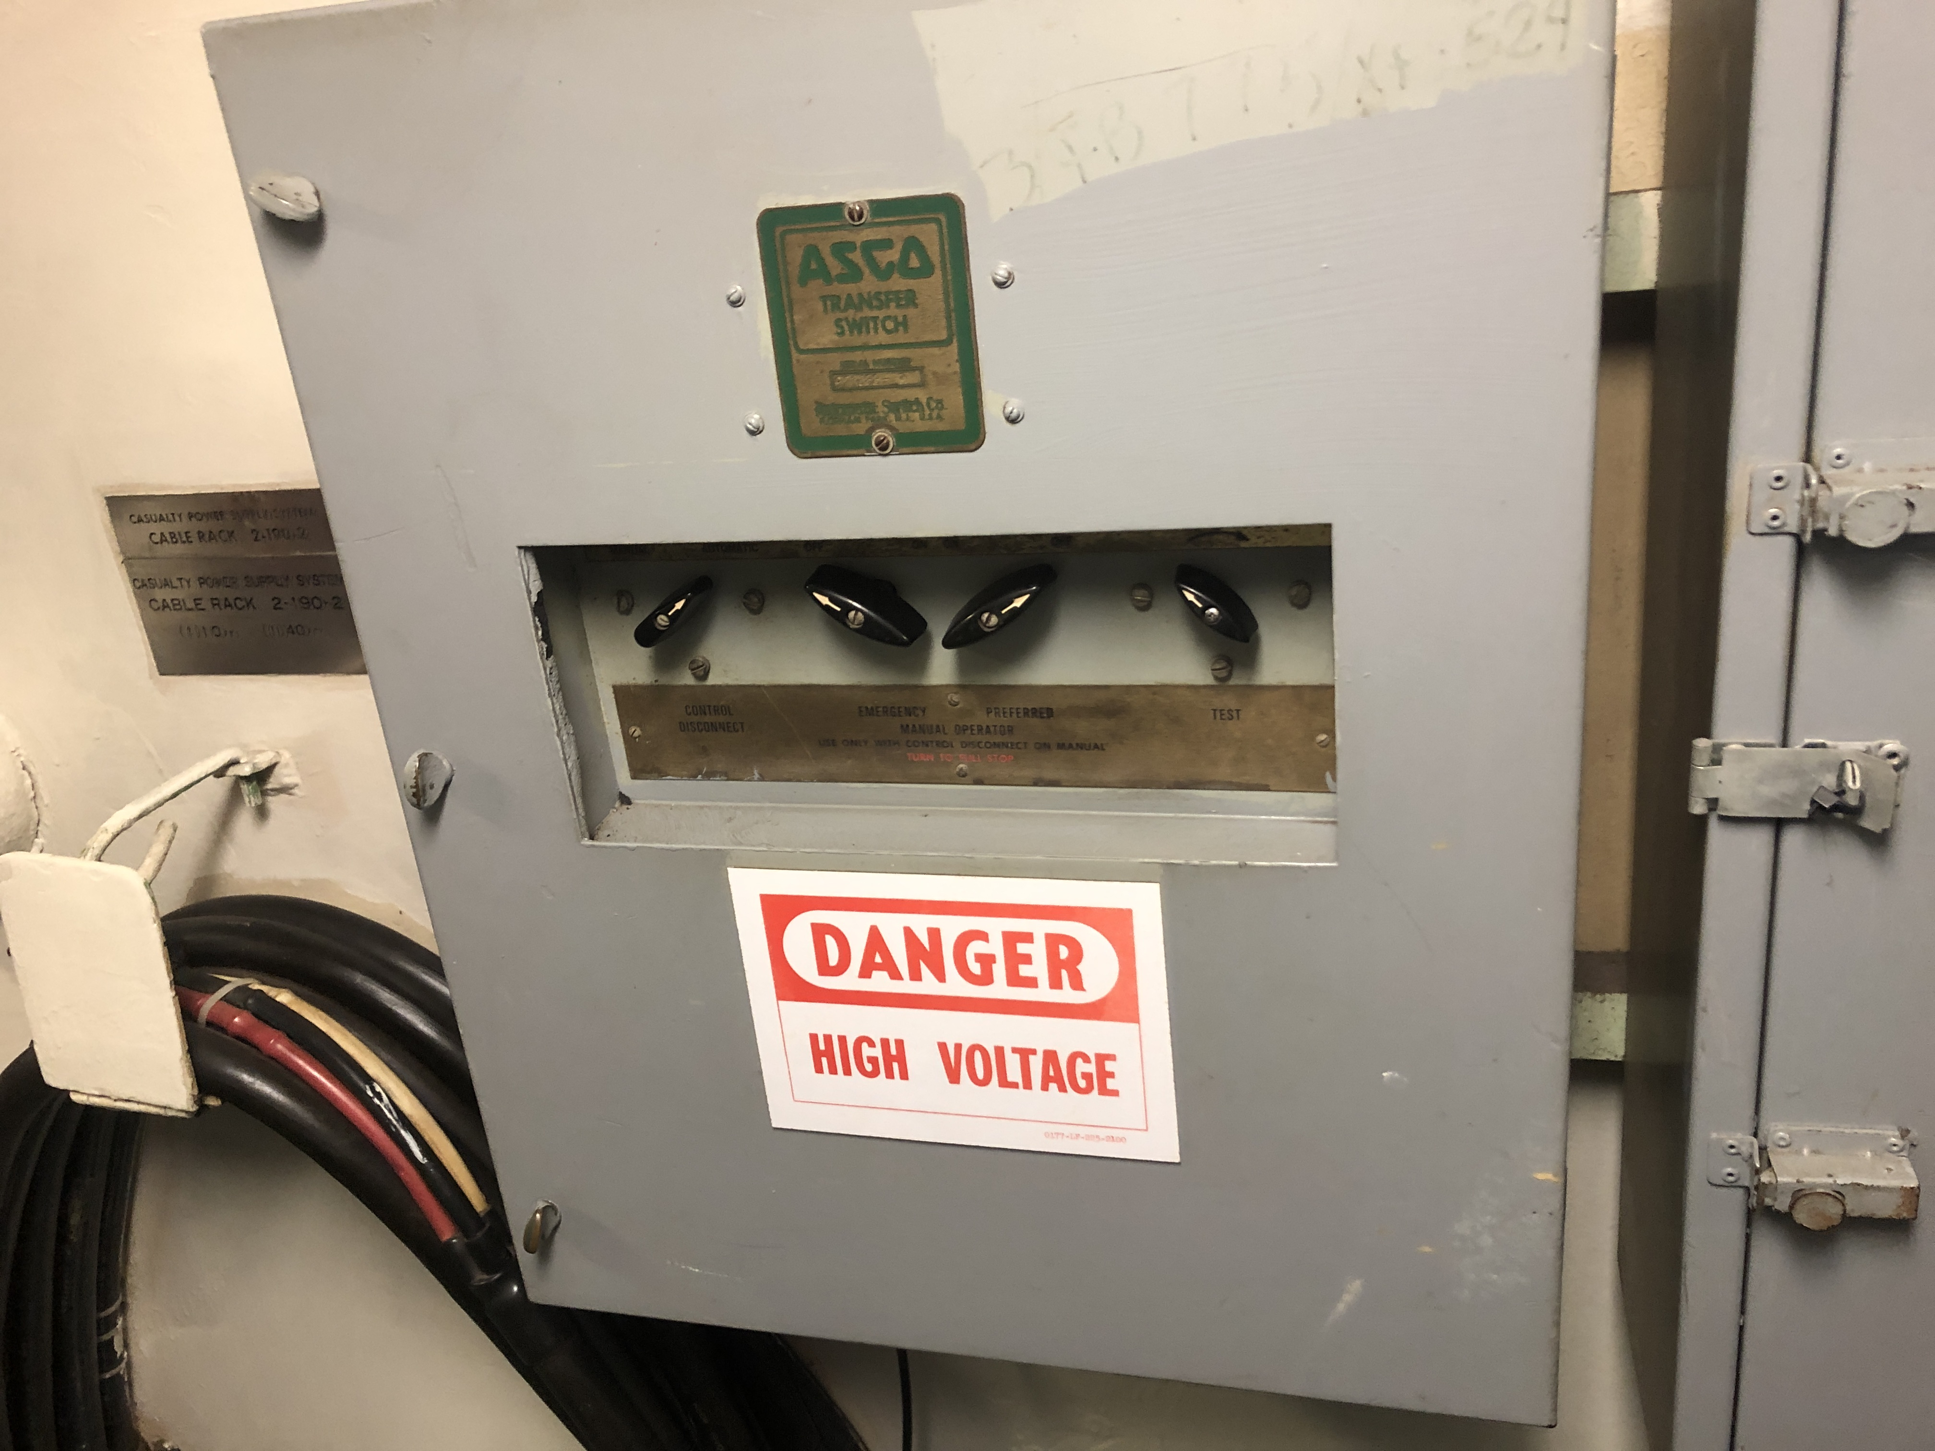
Figure 3: ASCO Transfer Switch (Image © 2022 Norbert Doerry – Licensed via CC BY 4.0)
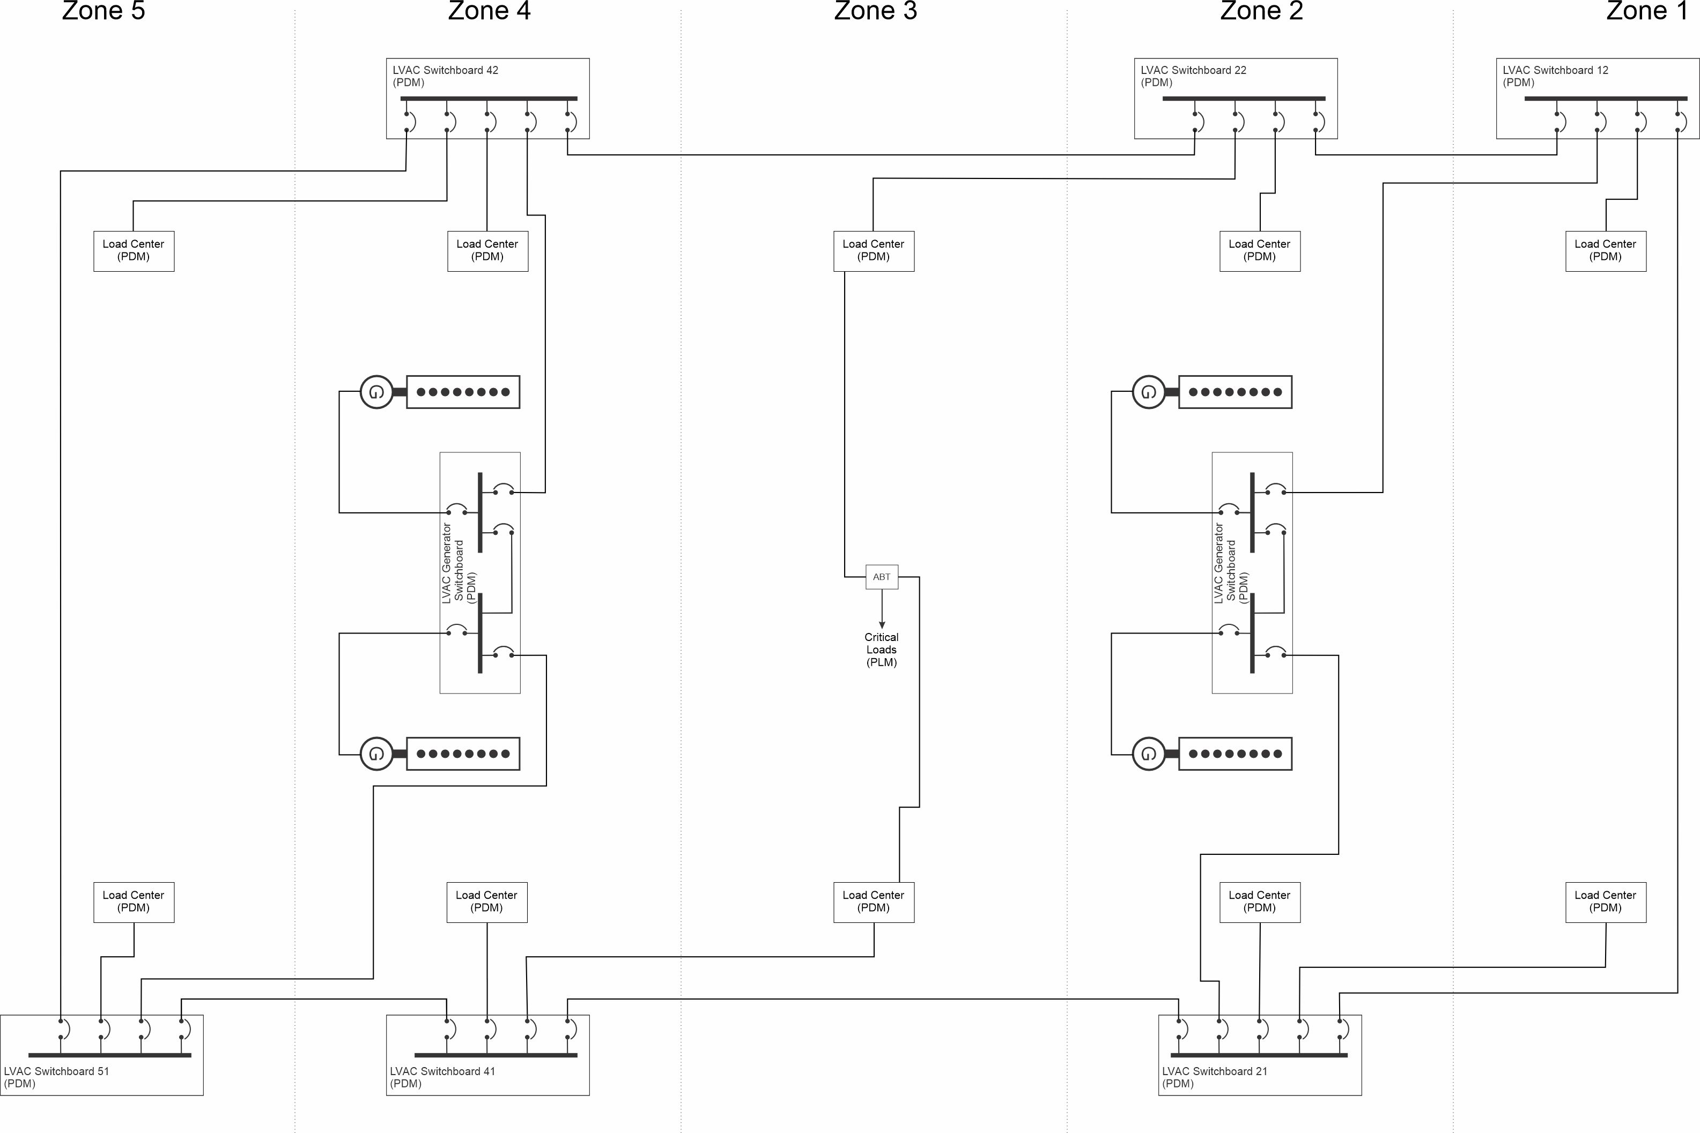
Figure 4: Zonal electrical distribution system with zone 3 load centers powered from switchboards fore and aft
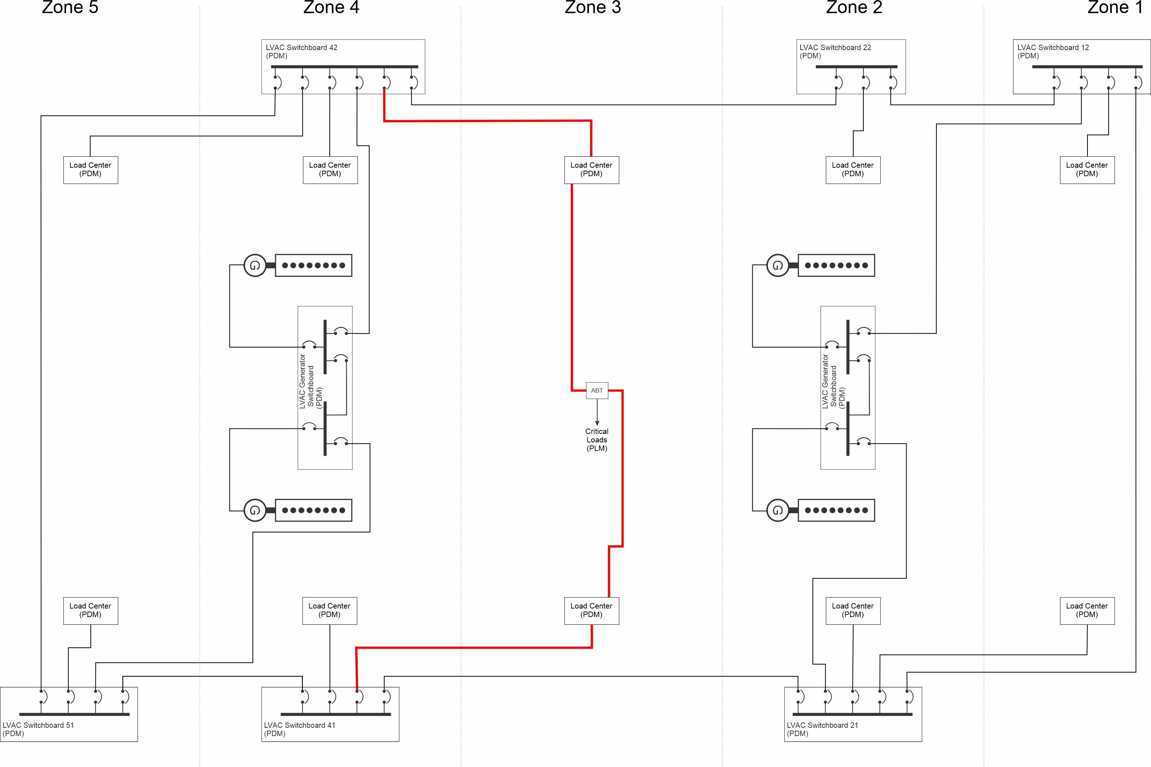
Figure 5: Zonal electrical distribution system with zone 3 load centers both powered from aft zone (not recommended)
In a non-zonal system, the normal and alternate sources for a bus transfer should be separated by at least two watertight bulkheads.
Since the bus transfer device and the cable from the bus transfer device to the served equipment is a single point of failure, they should be located close to the equipment served. Where possible, the normal and alternate feeders for bus transfer should be routed as far apart as practical. These practices maximize the chance that one of the two feeders will not be damaged if the served equipment is not damaged.
Before re-energizing equipment is a damaged zone, one should ensure that it is safe to do so. Re-energizing a fire pump with a discharge pipe that is holed ten feet from the fire pump will likely be counter-productive; one will then have to deal with flooding in addition to the original problem. The component’s system should be instrumented sufficiently, and procedures developed, to facilitate ship’s force in determining that the equipment may be safely started and operated.
  - Casualty power system
Casualty power systems are composed of a series of portable cables, permanently installed cables, connectors, and bulkhead penetrations designed to enable restoring power to undamaged equipment within a damaged zone or compartment. Figure 6 depicts a permanently installed terminal box with three connectors for portable cables. Figure 7 depicts a portable cable to connect between terminal boxes or between terminal boxes and equipment. MIL-DTL-24552 provides details on the different components of a casualty power system.
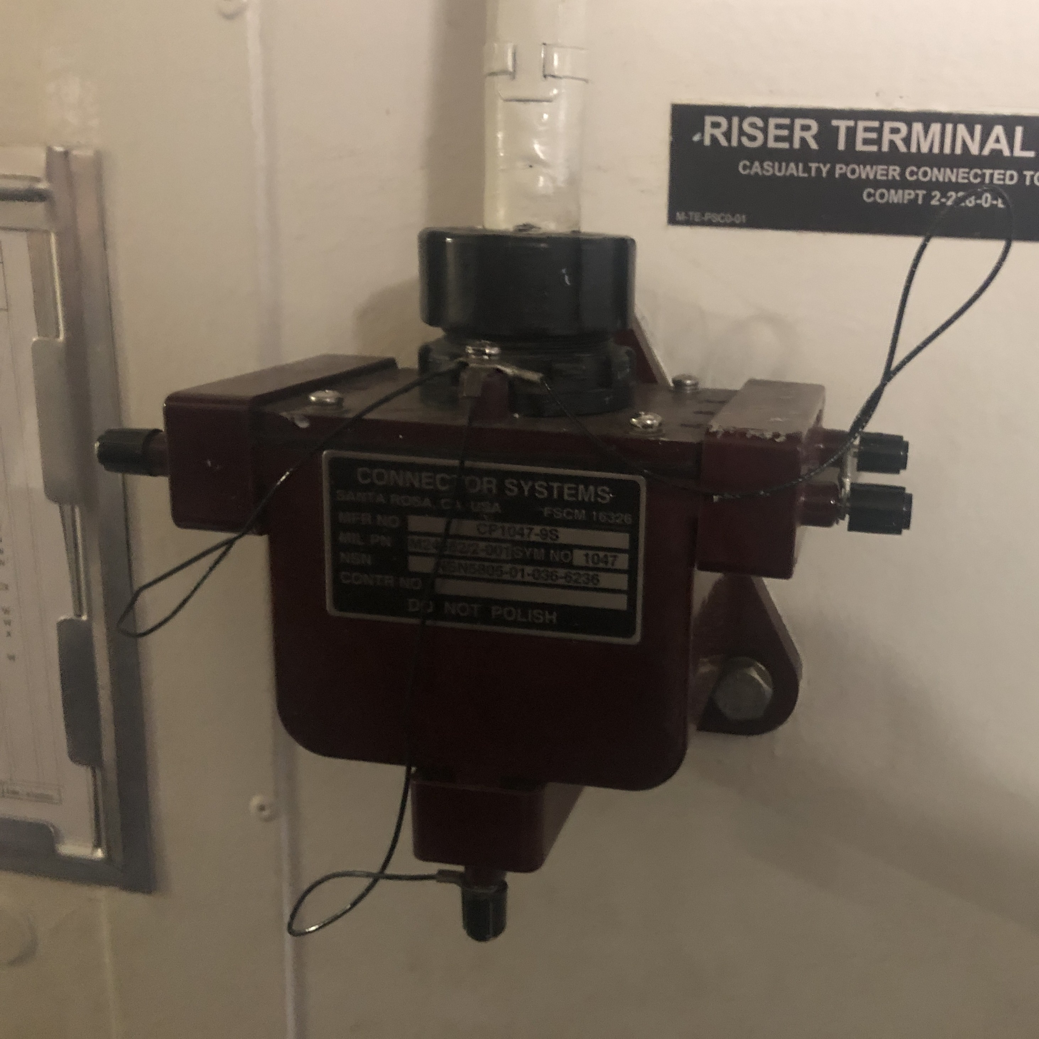
Figure 6: Casualty Power System Riser Terminal (Photo © 2024 Norbert Doerry, Licensed via CC BY 4.0)
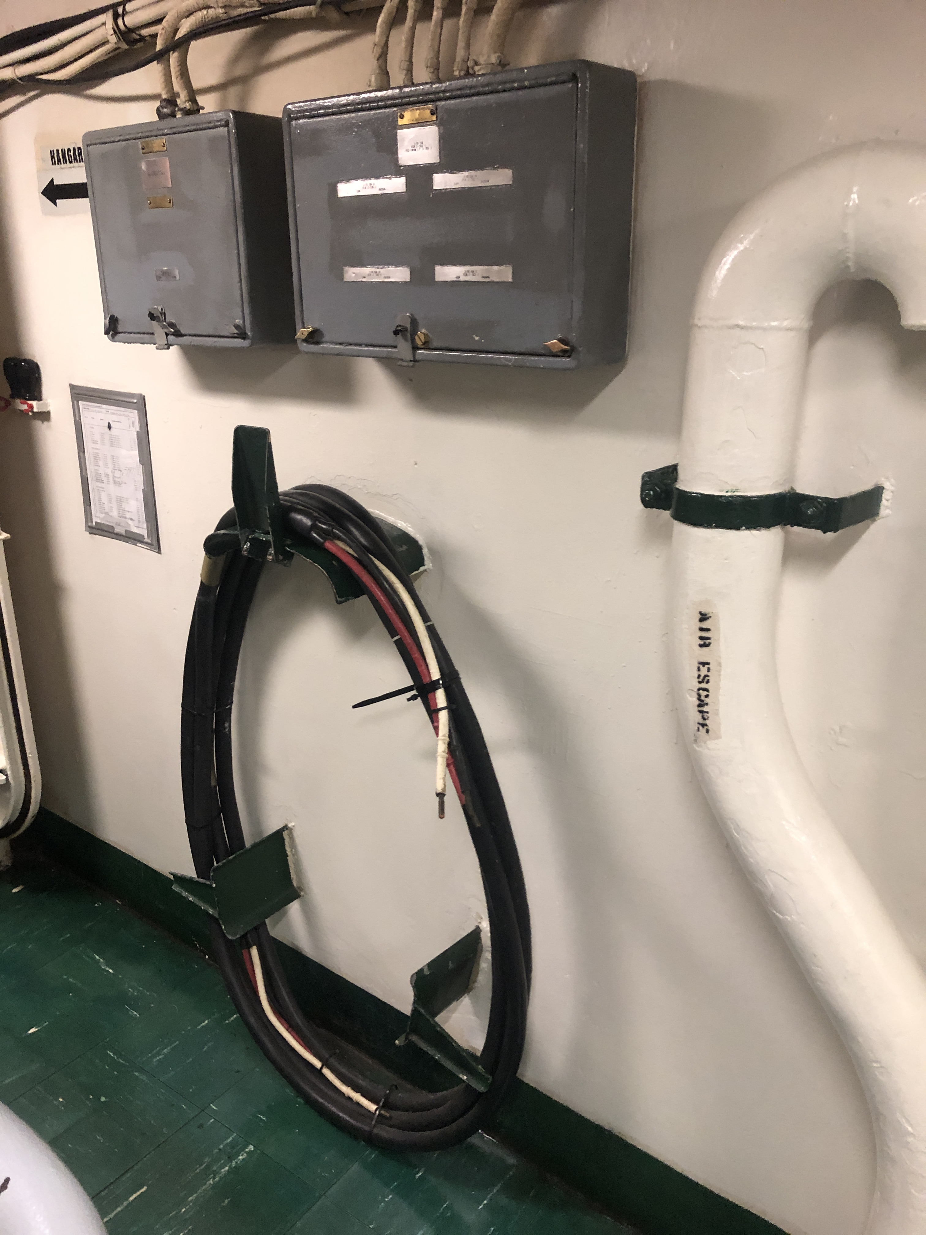
Figure 7: Casualty Power System Cable (old style termination) (Photo © 2022 Norbert Doerry, Licensed via CC BY 4.0)
- Dynamic positioning
The American Bureau of Shipping (ABS) offers classification notations for power and propulsion systems that adhere to the requirements of its “ABS Guide for Dynamic Positioning Systems” which is based on IMO MSC.1/Circ. 1580. In particular DPS-2 and DPS-3 notations provide an inherent level of survivability for the propulsion system:
“DPS-2 For vessels which are fitted with a dynamic positioning system which is capable of automatically maintaining the position and heading (Station Keeping) of the vessel within a specified operating envelope under specified maximum environmental conditions during and following any single fault, excluding a loss of compartment or compartments.
DPS-3 For vessels which are fitted with a dynamic positioning system which is capable of automatically maintaining the position and heading (Station Keeping) of the vessel within a specified operating envelope under specified maximum environmental conditions during and following any single fault, including complete loss of a compartment due to fire or flood.”
For non-zonal ships, requiring DPS-3 notation can be part of a design strategy for achieving design threat outcomes for the propulsion system.
- Evaluating survivability
  - Evaluating zonal survivability
The first step is to understand which loads require power following damage to achieve the capability required for the design threat outcome.
Zonal survivability is evaluated by examining multiple damaged zone cases corresponding to all of the individual zones and every set of two adjacent zones. Initially, one assumes the zones of a case are completely out of service; the remaining undamaged zones are examined to ensure sufficient generation capacity and connectivity to loads. One also checks to ensure sufficient loads remain in the undamaged zones to achieve the design threat outcome.
If a case is unable to achieve the design threat outcome, one should examine if it could be achieved if any one of multiple distribution buses within the damaged zones survives. If so, then if the distribution buses within the damaged zones are properly protected, then zonal survivability is achieved.
If energy storage is employed for generation capacity, then it should have sufficient energy to power the necessary loads to achieve the design threat outcome for as long as it takes to provide a more permanent connection (such as a casualty power system that connects zonal switchboards) or until the design threat outcome is no longer needed.
  - Evaluating compartment survivability
Evaluating compartment survivability is an extension of the evaluation of zonal survivability. For each case, all of the loads within the damaged zone that are designated to have compartment survivability are included in the evaluation to ensure there is sufficient connectivity and generation capacity in the undamaged zones.
In later stages of design, the routing of normal and alternate feeder cables is checked to ensure they are widely separated such that damage to one feeder cable is not likely to also damage the other feeder cable without also damaging the equipment too.
  - Evaluating survivability of non-zonal systems
In non-zonal systems, survivability is typically evaluating by assuming locations in the ship where a design threat is manifested. Damage to equipment from the design threat at the particular location is assessed, and the over all impact of the damage on the ability of ship to attain its design threat outcome is estimated.
If a design threat outcome is not attained, the ship design is modified and survivability is re-assessed. Unlike zonal design where global statements on survivability are made, positing damage locations and resulting damage effects is only an indicator of survivability; somewhat different damage locations that are not evaluated may still result in an unacceptable design threat outcome.
- References
ABS Guide for Dynamic Positioning Systems
IEEE Std 45.1 IEEE Recommended Practice for Electrical Installations on Shipboard--Design
IEEE Std 45.3 IEEE Recommended Practice for Electrical Installations on Shipboard--Systems Engineering
IMO MSC.1/Circ. 1582, Guidelines for Vessels and Units with Dynamic Positioning (DP) Systems
MIL-DTL-24552 Detail Specification - Terminals and Seals, Plugs and Switch, Casualty Power Systems, Receptacle type, General Specification For

